1. Export the SAS dataset from this URL as .txt, .xlsx:

<http://www.ats.ucla.edu/stat/sas/webbooks/reg/crime.sas7bdat>

**Answer: Not able to open the file**

**From Word**

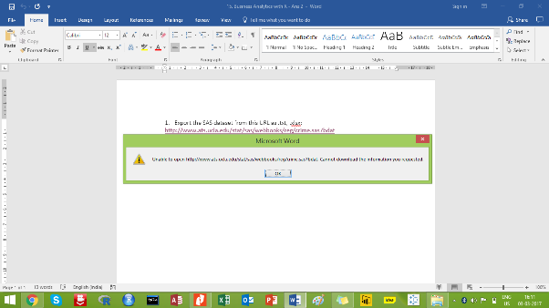

**From PDF**

